Continue with the JS Lessons
– click on the link below
https://www.khanacademy.org/computing/computer-programming
Get a pair of headphones!

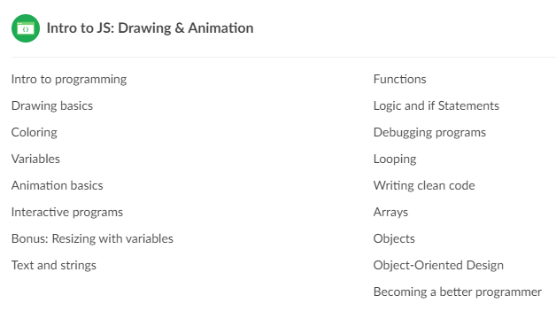
Make sure that you are signed in to Khan Academy and continue on the lesson where you left off from the previous day.

