Create a Free Account with Khan Academy – click on the link below
https://www.khanacademy.org/computing/computer-programming

- Click Sign up and create a free account.
- Join Khan Academy as a Learner
- Enter date of birth. Does not have to be actual birth date.
- Continue with Google
- Click - Let’s Go!

Get a pair of headphones!
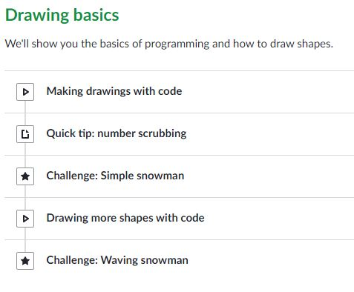
Begin with:
Intro to Programming
What is Programming? – 2 min video
Learning Programming on Khan Academy – Read
Drawing Basics – Demos and Challenges

