Digital Citizenship - A Vital Topic

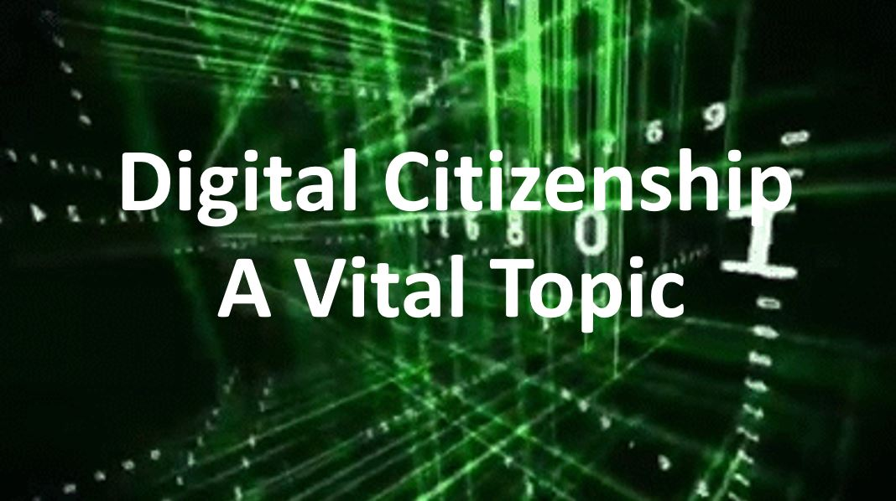

https://www.youtube.com/watch?v=SJCu7Y1AxOk&feature=youtu.be
