ASSIGNMENT - Use your Career Research Sheet and the Internet to create a Slideshow Presentation related to a career that you are interested in pursuing. Do not copy and paste text. Put it into your own words. You may use PowerPoint or Google Slides.

SLIDE 1 - Title Slide
*List the name of the career
*By: Your name
*Include a Theme or colored background
*Insert a related Gif image

SLIDE 2 - Career Navigation
Set up the slide below, but related to your career. Use textboxes, tables, and insert related images for each career category. Hyperlinks will be added from each category to it’s related slide (after all the slides are completed).
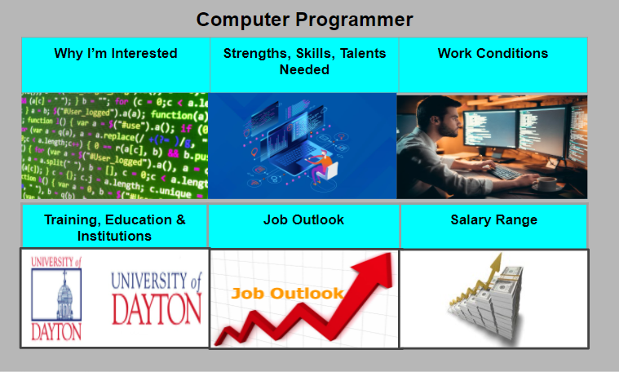

SLIDE 3 - Why I am Interested (Detail Slides)
*Insert a Shape and add/edit Text with information of why you are interested
*Insert a Shape/Arrow and create a return button to the Navigation slide
*Include a Theme or colored background
*Fill the rest of the slide by inserting related Gifs or images

SLIDES 4 - 8 (Detail Slides)
Create and layout the next 5 slides the same as in Slide 3.
Slide 4 - Strengths, Skills and Talents Needed
Slide 5 - Work Conditions
Slide 6 - Training, Education and Institutions
Slide 7 - Job Outlook
Slide 8 - Salary Range

- Hyperlinks will be created from each category in the Navigation Slide to each related slide. The Return Buttons will hyperlink back to the Navigation Slide.

