PIXLR X
Online PhotoShop

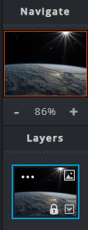
- SAVE 3 Google Images
* Scenic Background (outer space, beach, forest, desert, etc.)
* Individual (person, actor, actress, character, etc.)
* Random Image that will add humor to your creation (animal, car, airplane, pop can, etc.)

- OPEN PIXLR X
* Open https://pixlr.com/x/ Make sure you are using the PIXLR X program
* Click on OPEN IMAGE (left side of screen) and add your background image
* Click on the “+” in the Navigation Pane (Right side) to add your next layer (image)

- TIME TO GET CREATIVE!!!
* Save as many Images as you need. Add as many Layers as you want for your creation.
* Create your PhotoShopped project.
* Explore each of the PIXLR X Tools (left side of screen)

- SHOW YOUR WORK to Mr. Warren
SAVE YOUR WORK

