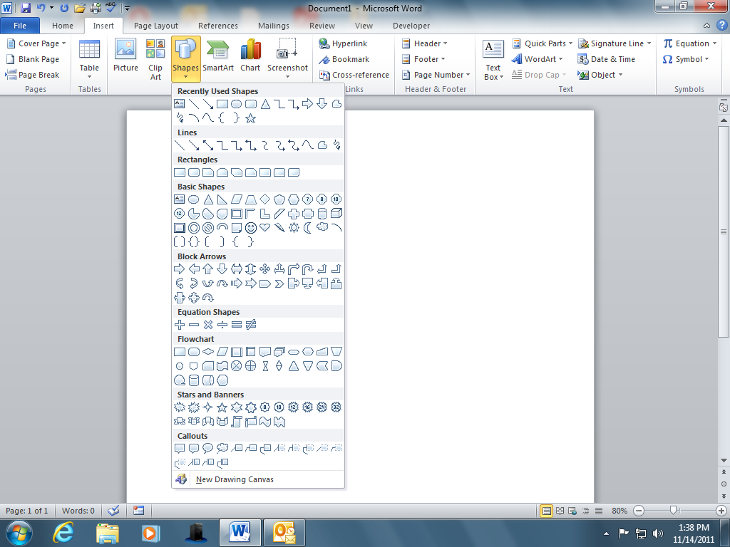
Shapes and Drawing Tools
Directions:
* Click on the INSERT tab.
* In the ILLUSTRATIONS group click
on the SHAPES command.
* Using the Shapes and Drawing
Tools create designs similar to the
examples below.

Directions:
* Click on the INSERT tab
* In the ILLUSTRATIONS group
click on the SHAPES
command.
* Using the Shapes and other
drawing tools create
designs similar to the
examples below.
below.

1. Insert an Arrow and change the line weight to 6pt.
(Drawing Tools - Format tab - Shape Outline).
Change the color of the line to a color you like.
2. Use the scribble tool to write your name.
Change the letters to different colors.

3. Insert a shape. Give the shape an effect
(i.e. Bevel, 3D rotation). Use the Shape Fill command
to fill it with a color or texture.
Good Morning!
4. Insert a Smiley Face. Give it a Gradient shape fill.
Insert a Callout (speech bubble). Add text in the callout.

I love using shapes and drawing tools!
5. Insert a Banner. Right click on the banner and select Add Text.
Add text. Give it a texture shape fill. Change the shape outline
weight.

6. Insert a Basic Shape. In Shape Outline change the line type
to Dashes. Then click on Edit Shape and practice using
Edit Points.
Before After Edited Points

7. Insert a Basic Shape. Make the shape 3D. Right click on the shape
and Select Format Shape. In the Format Shape task pane choose
Effects. Choose a 3D Rotation preset. Then select 3D Format and
change the Depth to a larger size. Use Shape fill and fill the shape
with a picture.

8. Create a drawing that uses multiple shapes. Use the curve tool in
your drawing. Group all of the different shapes in your drawing as 1
moveable object. Hold the Shift Key and click on each object. Then let
go of the Shift Key. While all of the shapes are still selected, right click on
the drawing and choose Group.

