Adobe Premiere Elements
Green Screen Directions

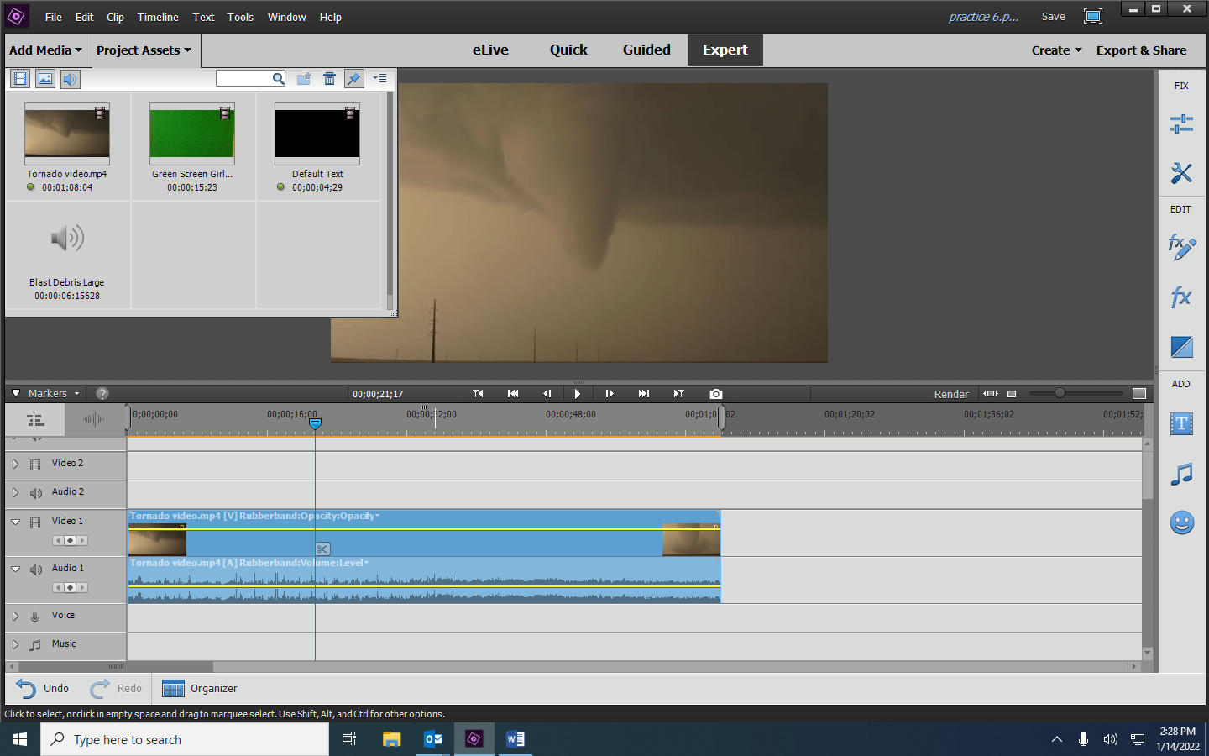
- After you add your media, click on Project Assets and drag your background video or background still image to the Video 1 track.

- Drag your green screen video clip into the Video 2 track.
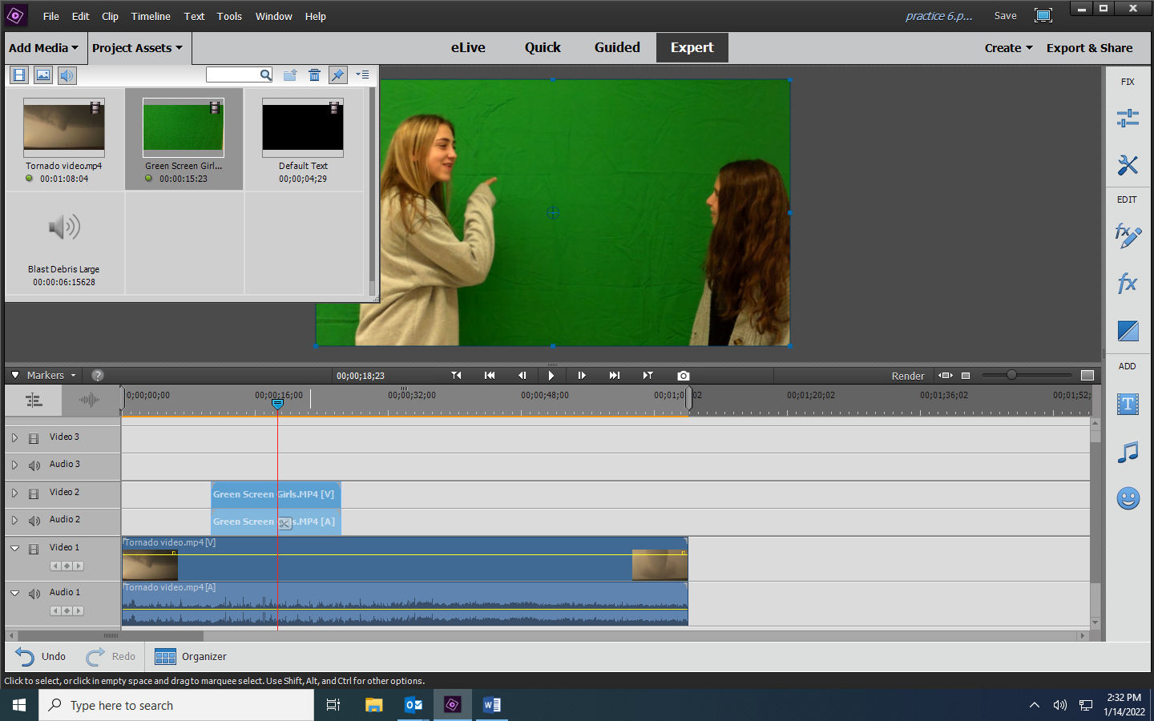

- Click on the fx command on the toolbar and select “Keying.”
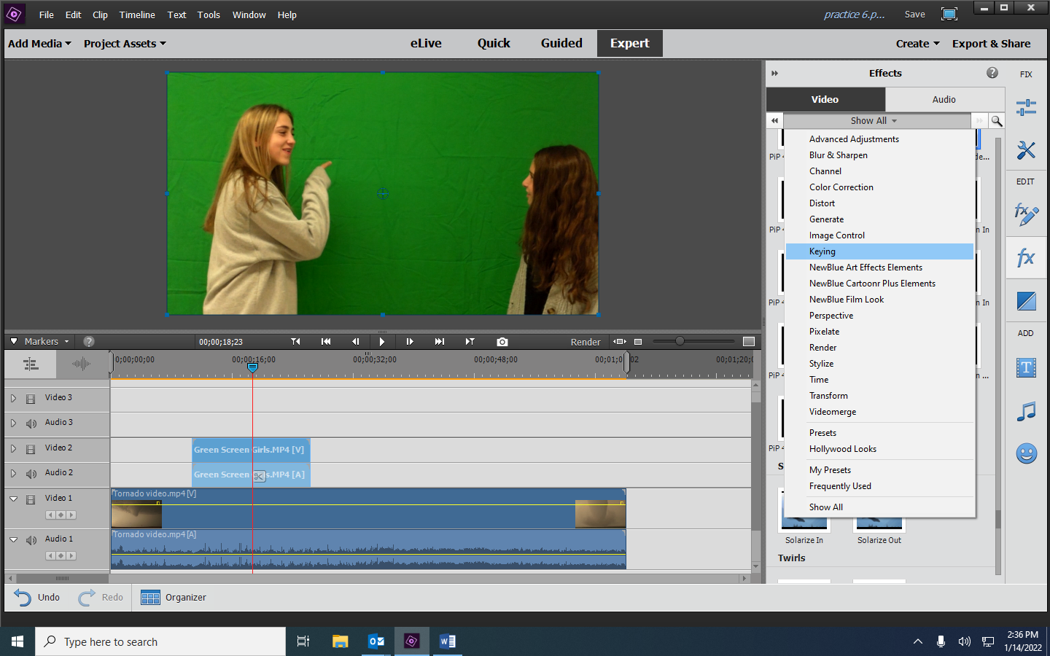

- Drag the Green Screen Key command to the top half (the video) of the green screen clip.
In Applied Effects adjust the Threshold and Cutoff as needed.
